How to Run the Source Code?

1. Download the source code on your local machine
2. Open the command prompt as “Administrator”

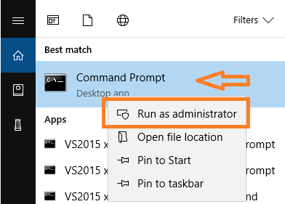

1. From command prompt set the path to the location where the downloaded source code is then type

*npm install*

* You should see *node_modules* folder when running npm install

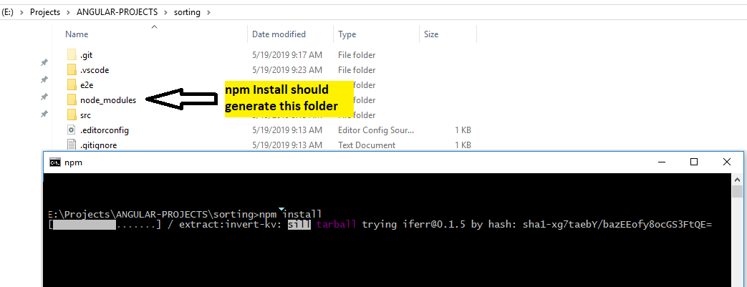

1. While still in command prompt enter *“ng s –o”*. Browser should open at localhost:4200

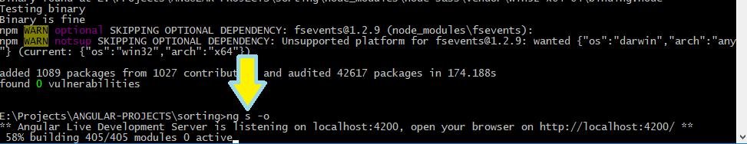

1. Output

